**PROJECT REPORT OF BRIGHT IDEAS CONSULTING**

**1.INTRODUCTION**

1.1 OVERVIEW

My project name is Bright Ideas Consulting (Professional Services - Industry). Bright Ideas Consulting, a consulting firm, relies on Zoho Books to track their billable hours, expenses, and client invoices. The software helps them accurately calculate project costs, monitor profitability, and generate reports for better financial management.Bright Ideas Consulting is a Private Limited company also registered under GST in Tamil Nadu. Bright Ideas Consulting offers various expert consulting services in India and outside India.

1.2 PURPOSE

Brightidea's Consulting Services professionals apply practical, real-world experience to help you create impactful innovation programs. Services cover: Establishing and scaling innovation teams and programs. Driving cultural change through a people-powered innovation approach.

**2.PROBLEM DEFINITION & DESIGN THINKING**

2.1 Empathy Map

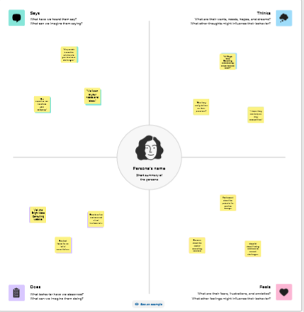

**2.2 Ideation & Brainstroming map**

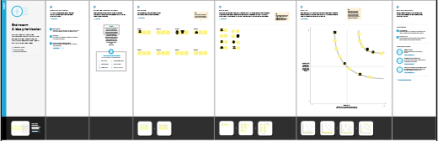

**3.RESULT**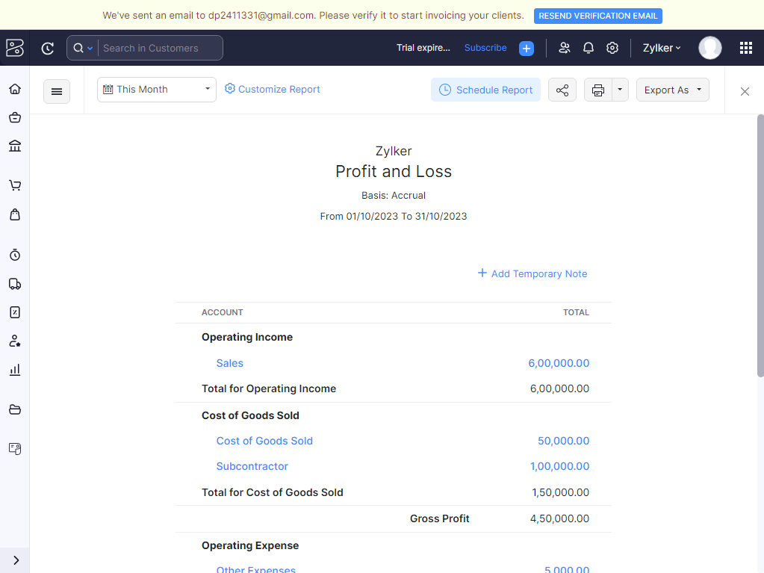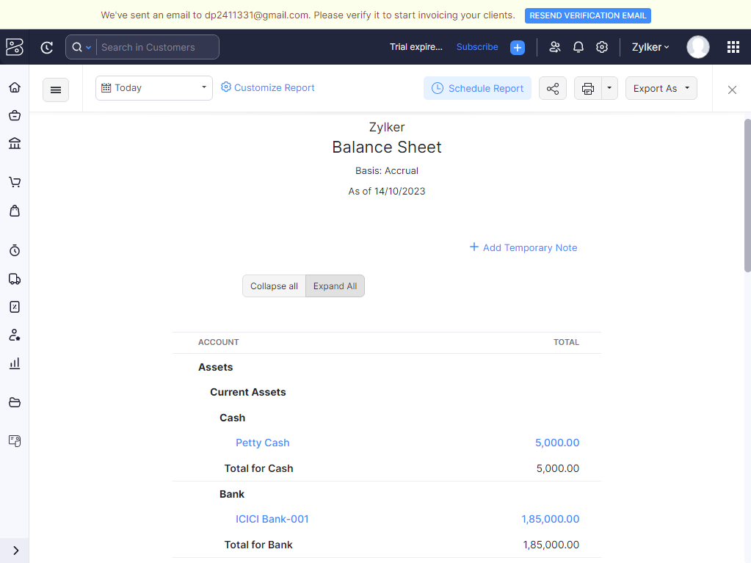

**4. ADVANTAGES & DISADVANTAGES**

**Advantages:**

1.Bright ideas is owned by Martin Hawthorne, a housing development professional with over 30 years’ experience . He coordinates all the company’s activity and can call upon the expertise of many other highly qualified and experienced colleagues to help tackle any issue you might have in the world of development. Delivering your Development Ambitions Bright Ideas can help you when you need us - you might have a staff shortage and need an experienced senior professional to help deliver your development requirements . This might mean a helping hand during a merger, a reorganisation, cover for maternity leave or to fill a gap after a senior member of staff has left . We can be brought in on a short-term basis to help offer strategic and practical help, as required.

**Disadvantages:**

Consulting often has high turnover rates, meaning that you may experience more coworker changes when working in consulting than you would expect when working as an employee at a company. This can make it harder to develop work relationships with your coworkers

**5. APPLICATIONS**

**GIT HUB AND ZOHO BOOKS** are used to applied the solution.

**6. CONCLUTION**

Consulting is a large part of Professional Services and is a key aspect of any Professional Services engagement. A business would usually pay for a consultant to work with them on a one-off project, helping them to make informed business decisions by using their technological and IT expertise

**7. FUTURE SCOPE**

The future of consulting should be predicated on greater senior partner engagement because increasingly there are no "generic" projects. Clients can no longer afford to waste time and money on junior consultants data crunching and trying to come up to speed with their business.